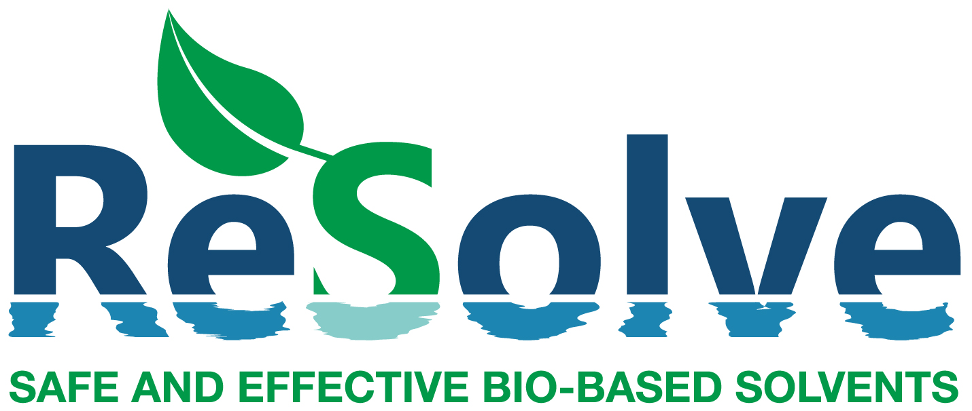

ReSolve Stakeholder Workshop at EFIB 2019

12:00 - 17:30 hrs, 30.09.19, The SQUARE Brussels convention centre, Brussels

Programme
12:00 | Lunch and registration
13:00 | Session 1: Safer solvent substitution
Dr. Petra Hogervorst
Netherlands National Institute of Public Health and the Environment (RIVM)

Integral assessment of safety and sustainability
The transition towards a circular economy requires innovation, but also brings along new challenges for safety and sustainability. RIVM increases the quality of circular solutions by helping the business community and government authorities in making choices and resolving dilemmas, for example by research on: safety of promising bio based alternatives to controversial polar aprotic solvents; mapping well-known and popular sustainability analyses and developing a tool to make sustainability questions easier and transparent during innovation and production, and developing a method for estimating the safety and sustainability of a product right at the beginning of a design process.

Dr. Jane Murray
Merck KGaA

Commercial introduction of novel green solvents to the global scientific community
Increasing the availability and application of greener solvents is a key goal of Merck KGaA’s green chemistry program. This talk will outline the importance of innovation partnerships, including ReSolve, in bringing new technologies to our portfolio. We will also discuss how we increase awareness of new technologies and facilitate our customers’ switch to sustainable alternatives through our green chemistry education programs.

14:00 | Coffee break
14:15 | Session 2: ReSolve project results so far
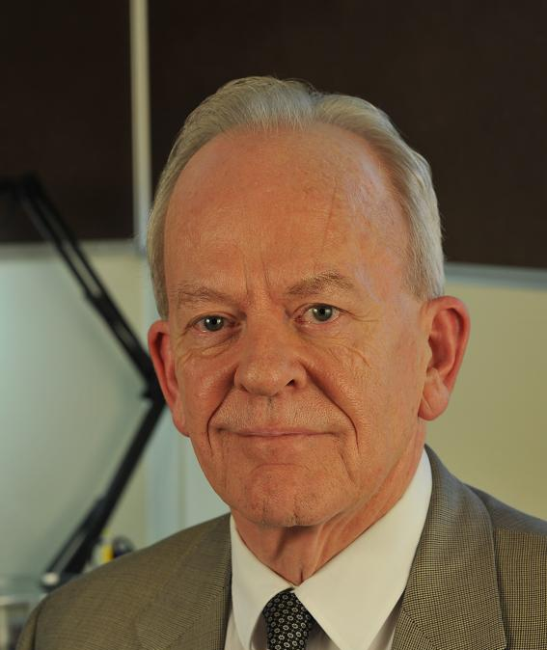 | Prof. James Clark  University of York  Introduction and highlights  The replacement of toxic and hazardous solvents with safer and more sustainable alternatives is one of the greatest current challenges in green chemistry and clean manufacturing.  The BBI project Resolve is tackling this challenge with a multidisciplinary team drawn from industry, business and academia with the aim of developing new bio-based solvents that can replace polar aprotic amide solvents and toluene. Polar aprotic solvents have been hit especially hard by new legislation notably REACH with many being classified as repro-toxins; virtually all of the current commercial solvents also suffer from the presence of hetero atoms such as N or S that can cause problems in any final disposal process. Like most amides, toluene is now restricted in use. All of these solvents have a remarkably diverse range of applications and their replacements are unlikely to be based on “drop ins” but are more likely to be tailor-made for an application. ReSolve has already identified a number of promising solvents and is helping to identify where they can be used as cost-effective, bio-based and safe solutions. Subsequent talks will highlight two of these both of which have passed our strict criteria for classification as being green and sustainable, and commercially viable, and where we can show a diverse range of successful applications.
Dr. Barbara M. A. van Vugt-Lussenburg
BioDetection Systems

An integrated testing strategy to evaluate toxicological safety issues of candidate solvents
For the successful substitution of fossil-derived solvents by bio-based alternatives, it is essential that these alternatives do not have similar hazardous properties. In ReSolve, the hazard profile of the replacement candidates is assessed in an early stage, using a combination of in silico and in vitro methodology. The in-silico approach uses a combination of QSAR-based toxicity predictions, and experimental toxicity data (if available) for so-called read across. The in vitro approach makes use of CALUX® reporter gene assays, which focus on molecular initiating and early key events that are the primary target of toxicants. In this presentation, this innovative integrated strategy will be described, and illustrated with several examples from the resolve project.

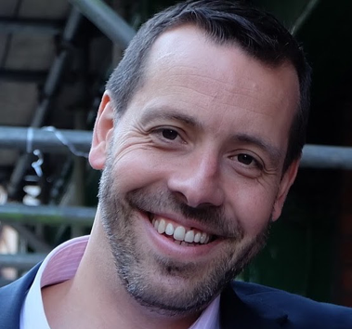 | Dr. Fabien Deswarte  Circa Sustainable Chemicals Ltd  Safer and high performing bio-based alternatives to NMP  One of the objectives of ReSolve is to develop safer and high-performing bio-based alternatives to NMP – a high-volume solvent facing intense regulatory pressure due to its reprotoxicity. From more than 100 potential candidates, six possible starting materials were identified and analysed using computer modelling to predict their properties. The most promising candidates were then synthesised to assess their hazard profile and the solvents that passed the toxicity screening were subjected to application testing. In this presentation we will present the most promising NMP alternatives and how they compare with NMP from a performance, TEE and LCA, point of view. This will include Cyrene – a solvent derived from wood waste, which was recently granted REACH Annex XIII approval and is now being produced at demonstration scale.
Dr. Fergal Byrne
University of York

Safer and high performing bio-based alternatives to toluene
Toluene is a common non-polar solvent used throughout the chemical industry. However, is a reprotoxin and is petroleum-derived. As such, alternatives are urgently sought. In this presentation, the top candidates to replace toluene are discussed. Four categories of analysis were carried out as part of ReSolve – synthesis, application testing, toxicity, TEE and LCA – and each candidate will be discussed in terms of these in comparison to toluene. In addition, an update about the status of the scale-up synthesis of TMO will be presented.

Dr. Ángel Puente
nova-Institut GmbH

TEE and LCA of the most promising NMP and Toluene alternatives
In this presentations, together with Fabien and Fergal, we will discuss the TEE and LCA of the NMP and toluene alternatives.

16:00 | Session 3: Feedback and discussion session  Challenges of solvent substitution and bringing new solvents to market
17:00 | Wrap-up
17:30 | EFIB 2019 pre-conference reception
 | All workshop attendees can join the EFIB 2019 welcome reception

